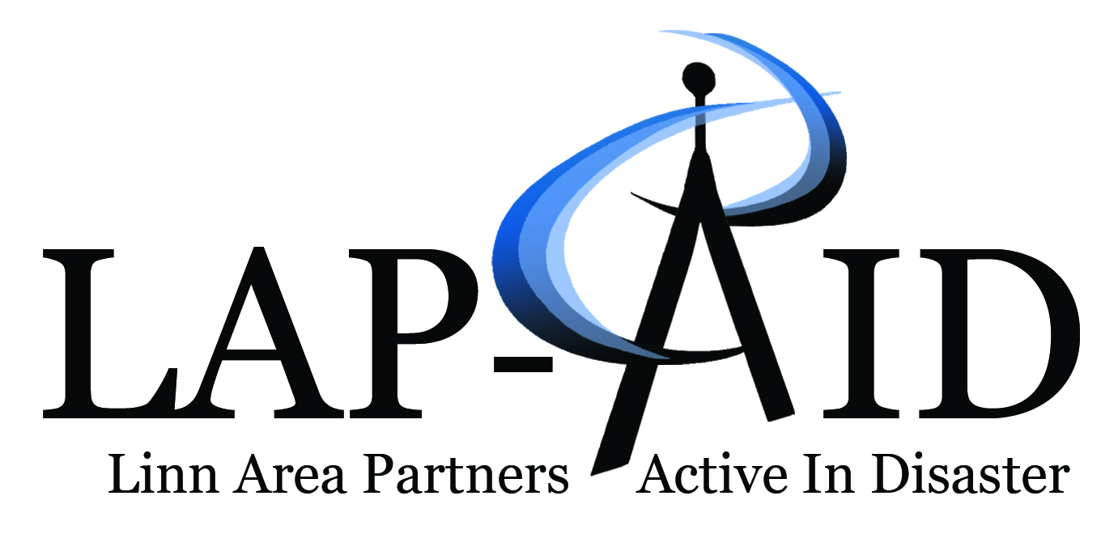
www.linndisasterinfo.org

Date: |  |  | Time:
The Linn Area Partners Active In Disaster (LAP AID) Executive Team (chair, vice chair, secretary, and treasure) has been notified by Linn County Emergency Management that LAP AID Team assistance is needed due to a disaster.

As Team Leaders of Linn Area Partners Active in Disasters (LAP AID), if your team is ACTIVIATED, please follow your activation protocol after review of information in this document.

If your team is NOT ACTIVATED, please provide your team a situational awareness of the situation.

The LAP AID Teams CHECKED below are Activated.
The Teams NOT activated are receiving this communication as awareness only.

Animal Care  Case Advocacy  Childcare & Children’s Services  Communications  Data Management  Mass Care  Medical Services |  | Mental Health Services  Needs Assessment  Older Adults & Special Needs  Volunteer Training & Coordination  Construction Coordination  Fundraising and Donations Management  Interfaith Spiritual Care
Scenario:
Information Needed:
Report Information Gathered to:

